Astro Fact

Journey of the solar system

Ahmed Hassan

371154

BSCS11A

Introduction

My website, Astro Facts, is a platform that provides users with interesting facts and quizzes related to our Solar System. It is specially designed for children. It is a simple and interactive website that aims to educate and entertain users about our home planet and the celestial bodies around it. It provides children with interesting facts about the solar system in very interactive and fun way.

Features

Astro Facts has three main webpages:

index.html: This is the homepage of your website. It welcomes the users and provides them with a brief description of what they can expect from the platform. It also includes two buttons that redirect the user to the "facts" and "quiz" pages.

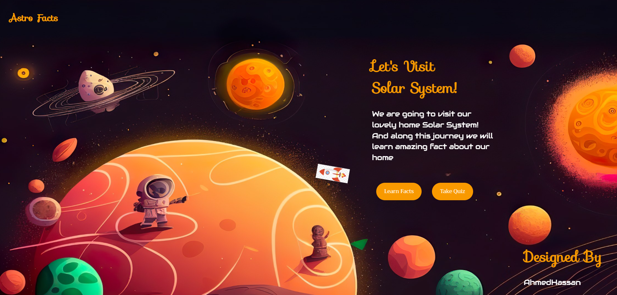

facts.html: This page provides the user with a list of interesting facts related to our Solar System. It is an interactive page that allows users to scroll through the facts and learn about the celestial bodies in our home planet.

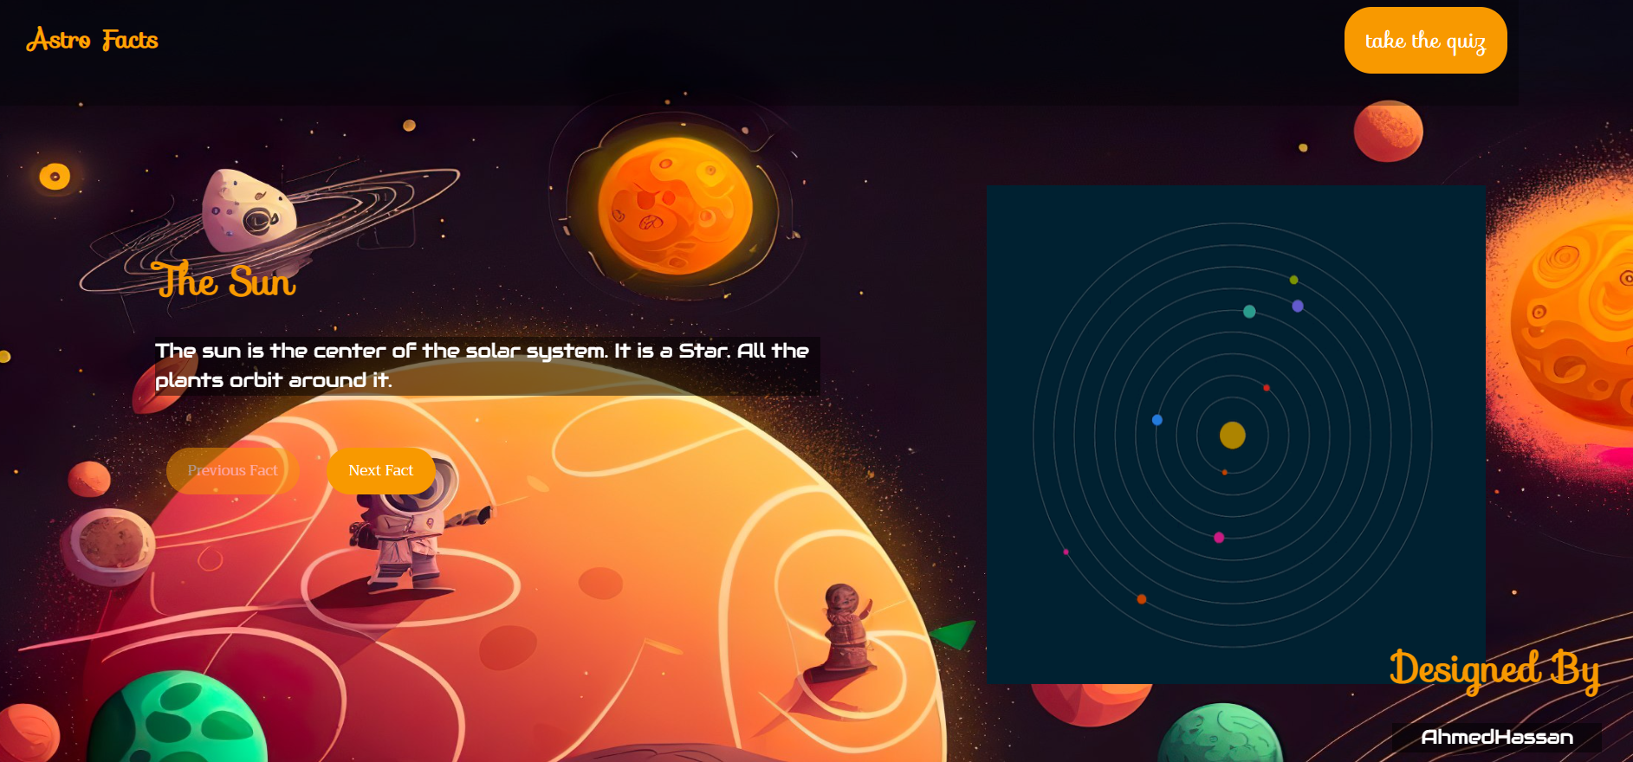

quiz.html: This page allows the user to take a quiz related to the facts they learned on the "facts" page. It is a fun and engaging way for users to test their knowledge about our Solar System.

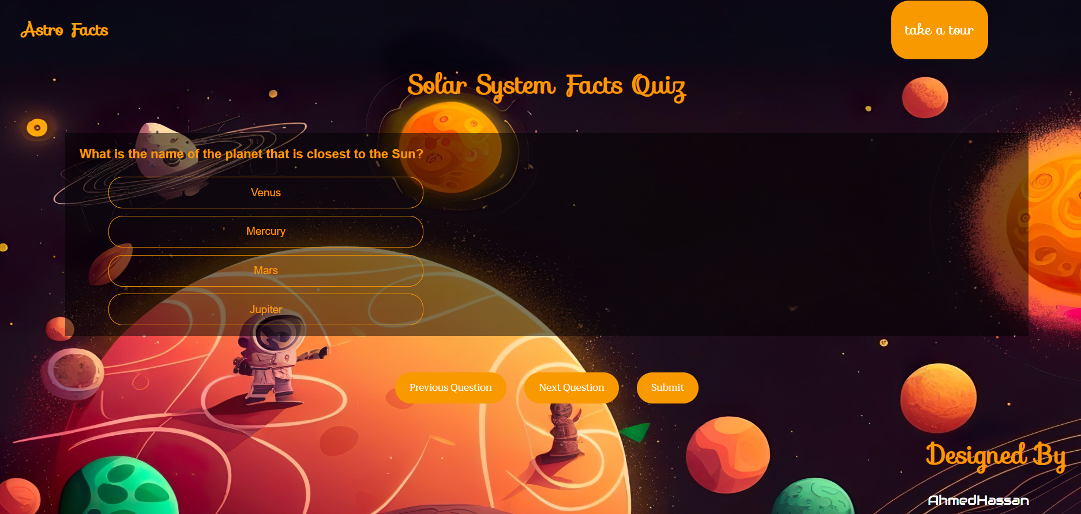

My website also includes a custom favicon, a responsive design, and animations that make the website more visually appealing.

Key learning points

in your own words While building this website, you had the opportunity to learn and practice the following skills:

HTML: I learned how to create webpages using HTML, including adding elements such as headers, paragraphs, links, and buttons.

CSS: I practiced styling the webpages using CSS, including adding fonts, colors, animations, and background images.

JS: I used java script to write a lot of functions and learn how to handle event in java script and how to make decisions based on user choice to make session more interactive.

Responsive design: I learned how to create a website that is responsive and can adapt to different screen sizes and devices.

Areas requiring improvement

While my website is functional and visually appealing, there are some areas that could be improved:

Content: While the facts provided on the "facts" page are interesting, they could be expanded and updated to include more information and recent discoveries.

Usability: While the website is easy to navigate, there are some small details that could be improved, such as making the buttons more prominent and increasing the contrast of some text.

Performance: While the website loads quickly, there are some optimizations that could be made to improve its performance, such as compressing images and minifying CSS and JavaScript files.

Overall, Astro Facts is a well-designed and educational website that offers users a fun and engaging way to learn about our Solar System. With some further improvements and updates, it has the potential to become an even better resource for users interested in astronomy and space exploration.